A Cat, a Parrot, and a Bag of Seed:

A man finds himself on a riverbank with a cat, a parrot and a bag of seed. He needs to transport all three to the other side of the river in his boat. However, the boat has room for only the man himself and one other item (either the cat, parrot or seed). In his absence, the cat could eat the parrot, and the parrot would eat the bag of seed. Show how he can get all the passengers to the other side, without leaving the wrong ones alone together.

1. **Define the problem**

a) I have to figure out how to get the man across the riverbank without leaving the cat with the parrot or the parrot with the seeds.

b) What insight can you offer into the problem that is not immediately visible from the word problem alone?

Figuring out that It is almost impossible to get across the riverbank without the cat eating the parrot and the parrot eating the seeds.

c) What is the overall goal?

To get the man, the parrot, the seeds, and the cat across the river.

1. **Break the problem apart**a) What are the constraints?

I can only allow the man and one other item in the boat.

b) What are the sub-goals?

* Get the cat across without it eating the parrot
* Get the parrot across without it eating the seeds.

1. **Identify potential solutions**a) For each of the sub-problems you’ve discussed in #2, what is a possible solution?

Maybe the parrot can fly back and forth with the man while he delivers the cat and the seeds to the other side.

1. **Evaluate each potential solution** 
   1. Does each solution meet the goals?

Yes

* 1. Will each solution work for ALL cases?

Yes

1. **Choose a solution and develop a plan to implement it.** 
   1. Explain the solution in full.

The man to put the cat in the boat with him and let the parrot fly at the same time. Once he drops the cat off, the parrot will fly back to the other side with him while he gets the seeds. They will them go back across the riverbank and meet the cat.

b) Describe some test cases you tried out to make sure it works. (You can include drawings and diagrams as part of your explanation as long as they are clearly communicating the solution).

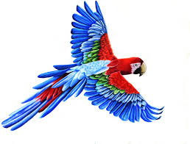



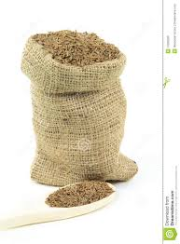

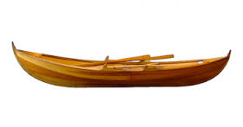

Socks in the Dark:

There are 20 socks in a drawer: 5 pairs of black socks, 3 pairs of brown and 2 pairs of white. You select the socks in the dark and can check them only after a selection has been made. What is the smallest number of socks you need to select to guarantee getting the following:

a) At least one matching pair  
b) At least one matching pair *of each color.*

1. **Define the problem**

a) I have to figure out how to get at least one matching pair of socks and at least one matching pair of sock in each color.b) What insight can you offer into the problem that is not immediately visible from the word problem alone?

Figuring out the estimate of how I could get the pairs of socks.

c) What is the overall goal?

Getting at least one pair of socks for each color.

1. **Break the problem apart**a) What are the constraints?

Figuring out how I would be able to get the least amount of socks.

b) What are the sub-goals?

To get at least one pair of socks.

1. **Identify potential solutions**a) For each of the sub-problems you’ve discussed in #2, what is a possible solution?

Counting all of the pairs of socks and estimating how many I could get.

1. **Evaluate each potential solution** 
   1. Does each solution meet the goals?

Yes

* 1. Will each solution work for ALL cases?

I believe so.

1. **Choose a solution and develop a plan to implement it.**

a) Explain the solution in full.

I have to count all of the socks, divide each color by the total number of socks and get the fraction of how many there are.

b) Describe some test cases you tried out to make sure it works. (You can include drawings and diagrams as part of your explanation as long as they are clearly communicating the solution).

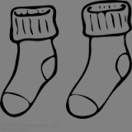

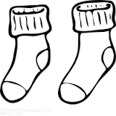

2

3

5

20

Predicting Fingers:

A little girl counts using the fingers of her left hand as follows: She starts by calling her thumb 1, the first finger 2, middle finder 3, ring finger 4, and little finger 5. Then she reverses direction, calling the ring finger 6, middle finger 7, first finger 8 and thumb 9, after which she calls her first finger 10 and so on. If she continues to count in this manner, on which finger will she stop?

a) What if the girl counts from 1 to 10 b) What if the girl counts from 1 to 100 c) What if the girl counts from 1 to 1000

1. **Define the problem**

a) If the girl counts on one hand to 10, 100, and 1000; which finger will she stop on?b) What insight can you offer into the problem that is not immediately visible from the word problem alone?

At first I thought she went to the other hand, but she stayed on the hand she was already on.

c) What is the overall goal?

To figure put what finger she will end on if she counts to 10, 100, and 1000.

1. **Break the problem apart**a) What are the constraints?

Figuring out if she will land on the first finger or the last finger.

b) What are the sub-goals?

Finding the solution.

1. I**dentify potential solutions**a) For each of the sub-problems you’ve discussed in #2, what is a possible solution?

Counting by fives or tens to figure out which finger she ends on each time.

1. **Evaluate each potential solution**

a) Does each solution meet the goals?

Yes it does.

b) Will each solution work for ALL cases?

Yes

1. **Choose a solution and develop a plan to implement it.**

a) Explain the solution in full.

Start on the finger she ended on, which was 10, on the first finger. Start by counting by fives or tens and she should end on the same finger each time, the first finger.   
b) Describe some test cases you tried out to make sure it works. (You can include drawings and diagrams as part of your explanation as long as they are clearly communicating the solution).

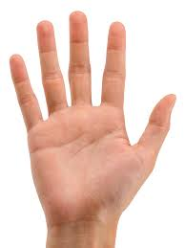

5

4, 6

3, 7

2, 8, 10

1, 9